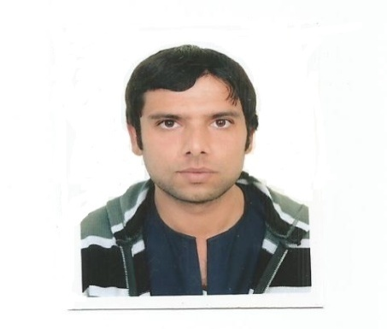

**RASHID AMIN**

**Mobile:00971-559369206⎢Email:rashidamin30@gmail.com**

**Address:Dubai, U.A.E**

**Visa Status: Visit Visa valid From 21st April to 07th July 2015**

**OBJECTIVES**

To obtain a challenging post at your reputable organization that will utilize both my educational background and professional experience to contribute to the organization's noble and humanitarian goals and simultaneously provide excellent opportunities for career development and personal growth.

**PERSONAL INFORMATION**

**Date of Birth. 1st April 1987**

**Marital Status. Married**

**Languages. Urdu and English**

**KEY SKILLS & EXPERTISE**

*Exclusive 3 years of Retail & Sales experience Building & leading high performance teams*

*Retail/Distribution Strategy Team Leadership & Motivation*

*Hard work, Integrity & Commitment*

**PROFESSIONALEXPERIENCE**.

***Supervisor & Admin Officer and Sales Manager***

Heena fashion Company.nit 1 wool wichst.blackburn BB1 3DA

feb 2010 – To dec 2010.

**Responsibilities:**

* Assist Manager with tasks including ordering stock from the warehouse, training new staff members, working out weekly rosters, merchandising new season stock, banking, resolving staff conflicts, theft prevention and was in charge of store when the manager was not on duty
* Increased sales with excellent customer service levels and developed good relationships with regular customers
* Assisted with the PR for the store by facilitating stylists needs and requests for magazine features
* Processed Internet sales and ensured their delivery.

Worked at Khanjra.(**Jan 2011 to Dec 2012)**

Address: Greenbank Business Park, Blakewater Road, Blackburn, Lancashire BB1 3HU, United Kingdom Phone:+44 1254 676793

**Worked at Aj Cash and Carry.(Jan 2013 to Dec 2013)**

Aj Buildings Dickens Street Blackburn Lancashire BB1 1RN

Phone:01254 504 750 ; 00447974111427

**BANK OF PUNJAB.** Completed internship of 6 months from 14 jan 2014 to 14 july 2014 in the bank of Punjab,branch kallar syedan RWP.0092513572235.

**Responsibilities.** Worked in account opening,cash,collection and remittance. And customer Services .

**EDUCATION**

**Matric ,** Fauji Foundation Model School Kallar Syedan (RWP) PAKISTAN (2004)

**ICS ,** Gordon College (RWP) PAKISTAN. (2006)

**B.COM**, Economics & Accounting Punjab Commerce College (RWP) *PAKISTAN. (2008)*

**TRAININGS**

* 3 month Auto Cad course from NICON.
* 3 month computer course.

**INTERESTS**

Reading financial magazines and articles Travelling Reading motivational books

**REFERENCES**

Available On Request